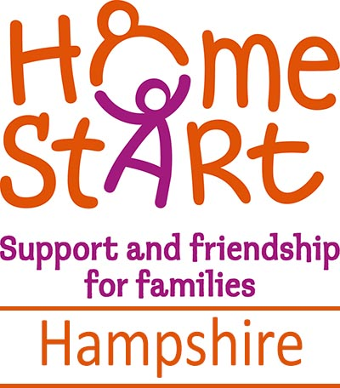
ENTRY FORM
Home-Start Hampshire - Meon Valley Office
Team Golf Event
Monday 20th May 2019
at Corhampton Golf Club
Shepherds Farm Lane, Corhampton, Southampton, SO32 3GZ

Closing date: Friday 3rd May
Start sheets will be emailed to Player 1

Name | Handicap
Player 1
Tel/Mobile
Email

Gift Aid Yes/No*
Player 2
Gift Aid Yes/No*
Player 3
Gift Aid Yes/No*
Player 3
Gift Aid Yes/No*
*Please add house number/name and postcode - essential to claim gift aid for each eligible player Declaration: I am a UK taxpayer and understand that if I pay less Income Tax and/or Capital Gains Tax in the current tax year than the amount of Gift Aid claimed on all my donations, it is my responsibility to pay any difference.

- I enclose cheque (payable to Home-Start Hampshire) for 4 players @ £37pp = £148
- I prefer to pay by BACS transfer for 4 players @ £37pp = £148
BACS: Home-Start Hampshire A/C No: 35405168 Sort Code 30-90-89
Essential reference: MVGolf followed by your surname
- I am unable to participate this time, but enclose a donation to Home-Start Hampshire

Please list any dietary requirements for your team here ___________________________

Please send Entry Form (and cheque if applicable)
by POST to Home-Start Hampshire, The Wickham Centre, Mill Lane, Wickham, PO17 5AL
Or EMAIL meon.valley@hshants.org.uk within 7 days of your BACS transfer
Home-Start Hampshire Meon Valley Office 01329 835936

Questions…..Pippa Maclean 01329 832119 or 07754 592318 or pippamaclean@icloud.com

